VLSI DESIGN AND AUTOMATION SUMMER INTERNSHIP
WEEK 4 SUBMISSION
RESOURCE: WEEK 1(ENC,NETLIST and DATA files are here)
VERILOG CODE AND WAVE FORM

- AND Gate
module and_gate(
input a, b,
output reg out);
always @(*) begin
if (a==1'b1 && b==1'b1)
out = 1'b1;
else
out = 1'b0;
end
endmodule
TB
module gate_and_TB();
reg a,b;
wire out;
and_gate dut(a, b, out);
initial begin
a = 0;
b = 0;
#10;

a = 0;
b = 1;
#10;

a = 1;
b = 0;
#10;

a = 1;
b = 1;
#10;

//$finish;
end
endmodule
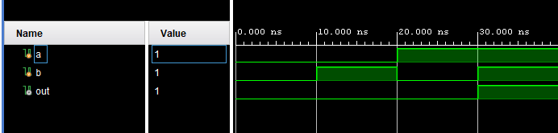

- OR gate
module gate_or(
input a, b,
output reg out);

always @(*) begin
if (a==1'b0 && b==1'b0)
out = 1'b0;
else
out = 1'b1;
end
endmodule
TB
module gate_or_tb;
reg a, b;
wire out;

gate_or uut (
.a(a),
.b(b),
.out(out)
);

initial begin
a = 0; b = 0; #10;
a = 0; b = 1; #10;
a = 1; b = 0; #10;
a = 1; b = 1; #10;
$finish;
end
endmodule
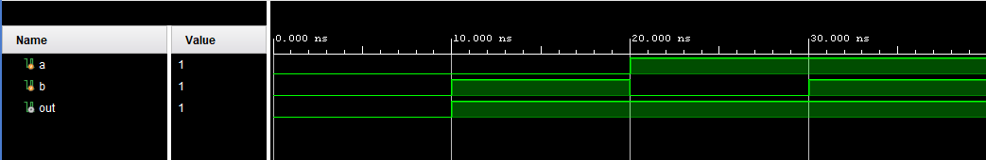
- NOT gate
module gate_not(
input in,
output out);

assign out = ~in;
endmodule
TB
module gate_not_tb;
reg in;
wire out;

gate_not uut (
.in(in),
.out(out)
);

initial begin
in = 0; #10;
in = 1; #10;
$finish;
end
endmodule
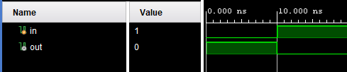
- NAND Gate
module nand_gate(
input a, b,
output reg out);
always @(*) begin
if (a==1'b1 && b==1'b1)
out = 1'b0;
else
out = 1'b1;
end
endmodule
TB
module nand_gate_tb;
reg a, b;
wire out;

nand_gate uut (
.a(a),
.b(b),
.out(out)
);

initial begin
a = 0; b = 0; #10;
a = 0; b = 1; #10;
a = 1; b = 0; #10;
a = 1; b = 1; #10;
$finish;
end
endmodule
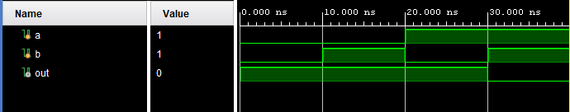

- NOR Gate
module gate_nor(
input a, b,
output reg out);

always @(*) begin
if (a==1'b0 && b==1'b0)
out = 1'b1;
else
out = 1'b0;
end
endmodule
TB
module gate_nor_tb;
reg a, b;
wire out;

gate_nor uut (
.a(a),
.b(b),
.out(out)
);

initial begin
a = 0; b = 0; #10;
a = 0; b = 1; #10;
a = 1; b = 0; #10;
a = 1; b = 1; #10;
$finish;
end
endmodule
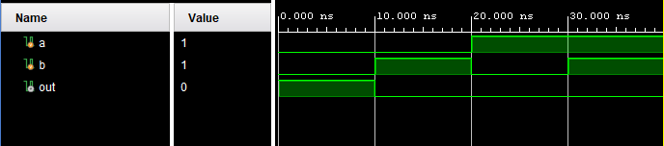
- XOR Gate
module gate_xor(
input a, b,
output reg out);

always @(*) begin
if ((a==1'b0 && b==1'b0) || (a==1'b1 && b==1'b1))
out = 1'b0;
else
out = 1'b1;
end
endmodule
TB
module gate_xor_tb;
reg a, b;
wire out;

gate_xor uut (
.a(a),
.b(b),
.out(out)
);

initial begin
a = 0; b = 0; #10;
a = 0; b = 1; #10;
a = 1; b = 0; #10;
a = 1; b = 1; #10;
$finish;
end
endmodule
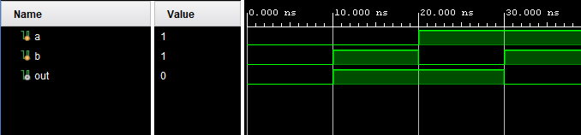
- XNOR Gate
module gate_xnor(
input a, b,
output reg out);

always @(*) begin
if ((a==1'b0 && b==1'b0) || (a==1'b1 && b==1'b1))
out = 1'b1;
else
out = 1'b0;
end
endmodule
TB
module gate_xnor_tb;
reg a, b;
wire out;

gate_xnor uut (
.a(a),
.b(b),
.out(out)
);

initial begin
a = 0; b = 0; #10;
a = 0; b = 1; #10;
a = 1; b = 0; #10;
a = 1; b = 1; #10;
$finish;
end
endmodule
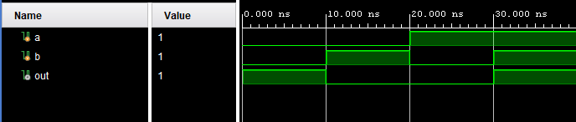
- Gate Combo
module gate_combo(
input a, b,
output out);

wire w0, w1, w2;

assign w0 = a^b;
assign w1 = w0&a;
assign w2 = w1|w0;
assign out = ~w2;

endmodule
TB
module gate_combo_tb;
reg a, b;
wire out;

gate_combo uut (
.a(a),
.b(b),
.out(out)
);

initial begin
a = 0; b = 0; #10;
a = 0; b = 1; #10;
a = 1; b = 0; #10;
a = 1; b = 1; #10;
$finish;
end
endmodule
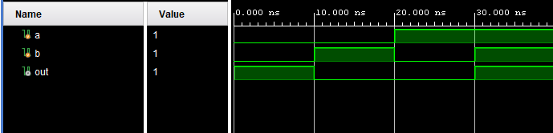
- 4 input AND Gate
module and4_gate(
input a, b, c, d,
output reg out);
always @(*) begin
if (a==1'b1 && b==1'b1 && c==1'b1 && d==1'b1)
out = 1'b1;
else
out = 1'b0;
end
endmodule
TB
module and4_gate_tb;
reg a, b, c, d;
wire out;

and4_gate uut (
.a(a),
.b(b),
.c(c),
.d(d),
.out(out)
);

initial begin
a = 0; b = 0; c = 0; d = 0; #10;
a = 0; b = 1; c = 1; d = 1; #10;
a = 1; b = 0; c = 1; d = 1; #10;
a = 1; b = 1; c = 0; d = 1; #10;
a = 1; b = 1; c = 1; d = 0; #10;
a = 1; b = 1; c = 1; d = 1; #10;
$finish;
end
endmodule
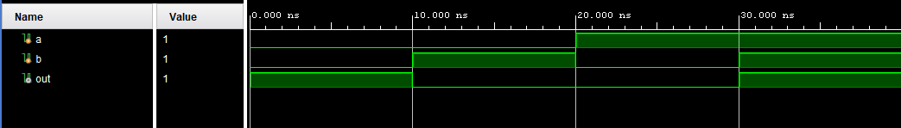
- 4 Input OR Gate
module gate_4or(
input a, b, c, d,
output reg out);

always @(*) begin
if (a==1'b0 && b==1'b0 && c==1'b0 && d==1'b0)
out = 1'b0;
else
out = 1'b1;
end
endmodule
TB
module gate_4or_tb;
reg a, b, c, d;
wire out;

gate_4or uut (
.a(a),
.b(b),
.c(c),
.d(d),
.out(out)
);

initial begin
a = 0; b = 0; c = 0; d = 0; #10;
a = 1; b = 0; c = 0; d = 0; #10;
a = 0; b = 1; c = 0; d = 0; #10;
a = 0; b = 0; c = 1; d = 0; #10;
a = 0; b = 0; c = 0; d = 1; #10;
a = 1; b = 1; c = 1; d = 1; #10;
$finish;
end
endmodule
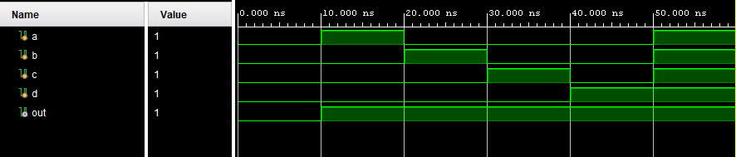
- Half Adder
module ha(
input a, b,
output sum, carry);

assign sum = a^b;
assign carry = a&b;

endmodule
TB
module ha_tb;
reg a, b;
wire sum, carry;

ha uut (
.a(a),
.b(b),
.sum(sum),
.carry(carry)
);

initial begin
a = 0; b = 0; #10;
a = 0; b = 1; #10;
a = 1; b = 0; #10;
a = 1; b = 1; #10;
$finish;
end
endmodule
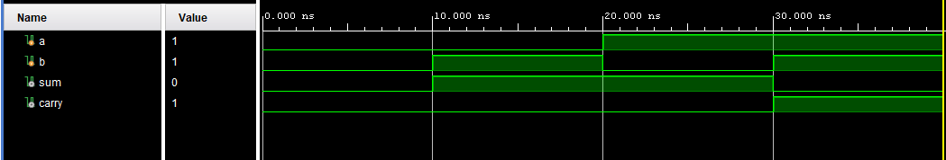
- Full Adder
module fa(
input a, b, c,
output sum, carry);

assign sum = a^b^c;
assign carry = (a&b) | (b&c) | (c&a);

endmodule
TB
module fa_tb;
reg a, b, c;
wire sum, carry;

fa uut (
.a(a),
.b(b),
.c(c),
.sum(sum),
.carry(carry)
);

initial begin
a = 0; b = 0; c = 0; #10;
a = 0; b = 0; c = 1; #10;
a = 0; b = 1; c = 0; #10;
a = 0; b = 1; c = 1; #10;
a = 1; b = 0; c = 0; #10;
a = 1; b = 0; c = 1; #10;
a = 1; b = 1; c = 0; #10;
a = 1; b = 1; c = 1; #10;
$finish;
end
endmodule
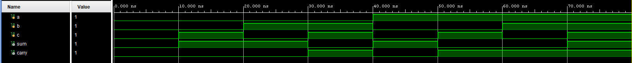
- 4 Bit Ripple Carry Adder
module rca4(
input [3:0] a, b,
input cin,
output [3:0] sum,
output cout);

wire [2:0] w;

fa u0(a[0], b[0], cin, sum[0], w[0]);
fa u1(a[1], b[1], w[0], sum[1], w[1]);
fa u2(a[2], b[2], w[1], sum[2], w[2]);
fa u3(a[3], b[3], w[2], sum[3], cout);

endmodule
TB
module rca4_tb;
reg [3:0] a, b;
reg cin;
wire [3:0] sum;
wire cout;

rca4 uut (
.a(a),
.b(b),
.cin(cin),
.sum(sum),
.cout(cout)
);

initial begin
a = 4'b0000; b = 4'b0000; cin = 0; #10;
a = 4'b0001; b = 4'b0010; cin = 0; #10;
a = 4'b0101; b = 4'b0011; cin = 1; #10;
a = 4'b1111; b = 4'b0001; cin = 0; #10;
a = 4'b1010; b = 4'b0101; cin = 1; #10;
$finish;
end
endmodule
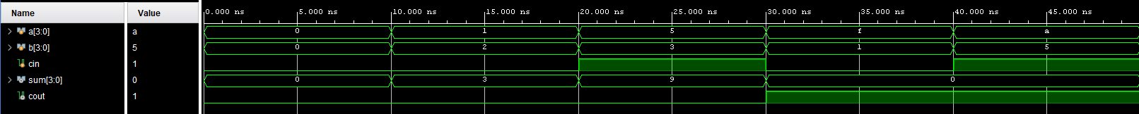
- 4 Bit Subtractor
module sub4(
input [3:0] a, b,
output [3:0] diff,
output borrow
);

wire [4:0] temp;

assign temp = {1'b0, a} - {1'b0, b};
assign diff = temp[3:0];
assign borrow = temp[4];

endmodule
TB
module sub4TB;

reg [3:0] a, b;
wire [3:0] diff;
wire borrow;

sub4 uut (
.a(a),
.b(b),
.diff(diff),
.borrow(borrow)
);

initial begin
a = 4'b0110; b = 4'b0011; #10;
a = 4'b1000; b = 4'b0100; #10;
a = 4'b0011; b = 4'b1000; #10;
a = 4'b1111; b = 4'b0001; #10;
$finish;
end

endmodule
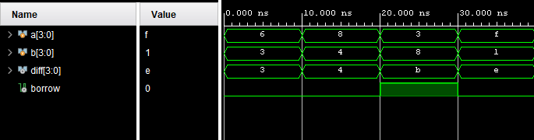

- 4 Bit ADDER Subtractor
module add_sub4(
input [3:0] a, b,
input sel, // sel = 0 for addition, sel = 1 for subtraction
output [3:0] result,
output carry_borrow
);

wire [3:0] b_xor;
wire cin;
assign b_xor = b ^ {4{sel}}; // XOR b with sel: if sel=1, invert b (2's comp)
assign cin = sel;

assign {carry_borrow, result} = a + b_xor + cin;

endmodule
TB
module add_sub4TB;

reg [3:0] a, b;
reg sel;
wire [3:0] result;
wire carry_borrow;

add_sub4 uut (
.a(a),
.b(b),
.sel(sel),
.result(result),
.carry_borrow(carry_borrow)
);

initial begin
a = 4'b0101; b = 4'b0011; sel = 0; #10; // 5 + 3
a = 4'b1000; b = 4'b0100; sel = 0; #10; // 8 + 4
a = 4'b0110; b = 4'b0011; sel = 1; #10; // 6 - 3
a = 4'b0010; b = 4'b0101; sel = 1; #10; // 2 - 5
$finish;
end

endmodule
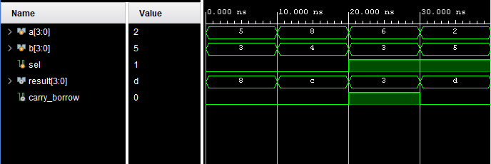

- Mux 2X1
module mux_2X1(
input a, b,sel,
output q
);

assign q = (sel) ? b : a;

endmodule
TB
module mux_2X1_TB();
reg a, b, sel;
wire q;

mux_2X1 dut(a, b, sel ,q);

initial begin
a = 0;
b = 0;
sel = 0;
#10;

a = 1;
b = 0;
sel = 0;
#10;

a = 1;
b = 0;
sel = 1;
#10;

a = 0;
b = 1;
sel = 0;
#10;

a = 0;
b = 1;
sel = 1;
#10;

end

endmodule
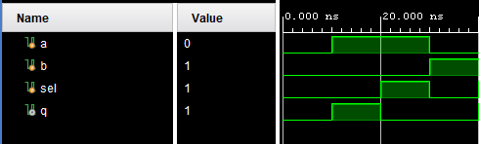
- MUX 4X1
module mux_4X1(
input [3:0] in,
input [1:0] sel,
output reg q);

always @(*) begin
case (sel)
2'b00 : q = in[0];
2'b01 : q = in[1];
2'b10 : q = in[2];
2'b11 : q = in[3];

endcase
end
endmodule
TB
module mux_4X1_tb;
reg [3:0] in;
reg [1:0] sel;
wire q;

mux_4X1 uut (
.in(in),
.sel(sel),
.q(q)
);

initial begin
in = 4'b1010;

sel = 2'b00; #10;
sel = 2'b01; #10;
sel = 2'b10; #10;
sel = 2'b11; #10;

$finish;
end
endmodule
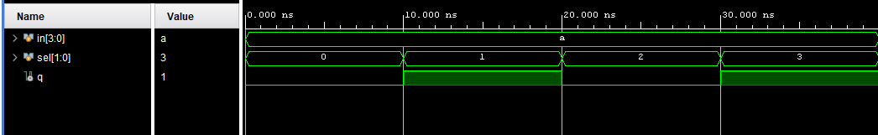
- MUX 8X1
module mux_8X1(
input [7:0] in,
input [2:0] sel,
output reg q);

always @(*) begin

case (sel)
3'b000 : q = in[0];
3'b001 : q = in[1];
3'b010 : q = in[2];
3'b011 : q = in[3];
3'b100 : q = in[4];
3'b101 : q = in[5];
3'b110 : q = in[6];
3'b111 : q = in[7];

endcase
end
endmodule
TB
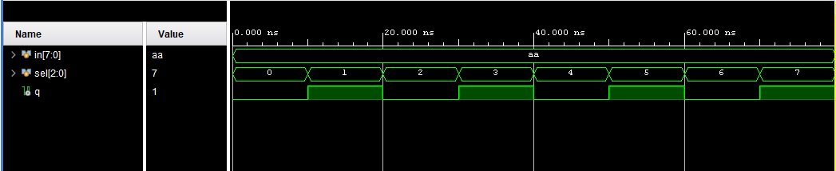
- DEMUX 1X2
module demux_1X2(
input a, sel,
output [1:0] out);

assign out = a << sel;

endmodule
TB
module demux_1X2_tb;
reg a, sel;
wire [1:0] out;

demux_1X2 uut (
.a(a),
.sel(sel),
.out(out)
);

initial begin
a = 0; sel = 0; #10;
a = 1; sel = 0; #10;
a = 1; sel = 1; #10;
a = 0; sel = 1; #10;
$finish;
end
endmodule
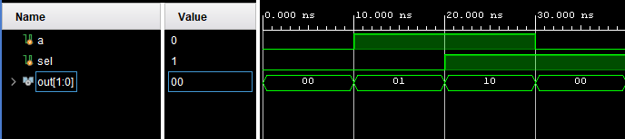
- DEMUX 1X4
module demux_1X4(
input a,
input [1:0] sel,
output reg [3:0] q);

//assign q = a << sel;
always @(*) begin
case (sel)
2'b00 : q[0] = a;
2'b01 : q[1] = a;
2'b10 : q[2] = a;
2'b11 : q[3] = a;
endcase
end
endmodule
TB
module demux_1X4_tb;
reg a;
reg [1:0] sel;
wire [3:0] q;

demux_1X4 uut (
.a(a),
.sel(sel),
.q(q)
);

initial begin
a = 1;

sel = 2'b00; #10;
sel = 2'b01; #10;
sel = 2'b10; #10;
sel = 2'b11; #10;

a = 0; sel = 2'b10; #10;

$finish;
end
endmodule
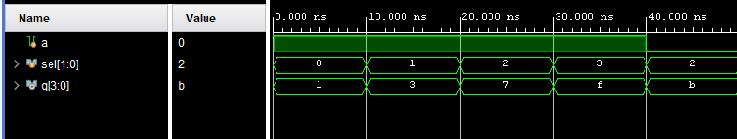
- Decoder 2X4
module decod_2X4(
input [1:0] a,
output reg [3:0] out);
always @(*) begin
case (a)
2'b00 : out[0] = 1'b1;
2'b01 : out[1] = 1'b1;
2'b10 : out[2] = 1'b1;
2'b11 : out[3] = 1'b1;
endcase
end
endmodule
TB
module decod_2X4_tb;
reg [1:0] a;
wire [3:0] out;

decod_2X4 uut (
.a(a),
.out(out)
);

initial begin
a = 2'b00; #10;
a = 2'b01; #10;
a = 2'b10; #10;
a = 2'b11; #10;
$finish;
end
endmodule
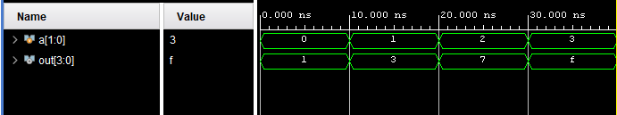
- Decoder 3X8
module decod_3X8(
input [2:0] a,
output [7:0] out);

assign out = 8'b00000001 << a;
endmodule
TB
module decod_3X8_tb;
reg [2:0] a;
wire [7:0] out;

decod_3X8 uut (
.a(a),
.out(out)
);

initial begin
a = 3'b000; #10;
a = 3'b001; #10;
a = 3'b010; #10;
a = 3'b011; #10;
a = 3'b100; #10;
a = 3'b101; #10;
a = 3'b110; #10;
a = 3'b111; #10;
$finish;
end
endmodule
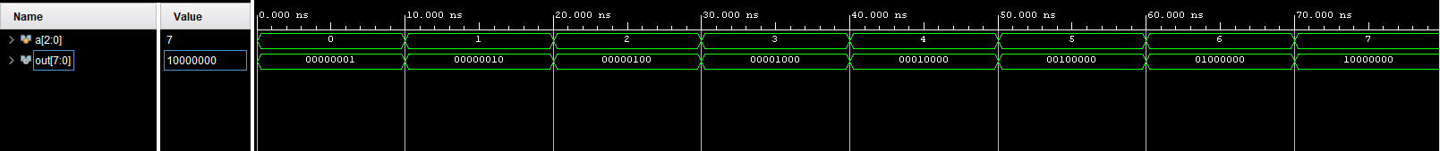
- Encoder 4X2
module encod_4X2(
input [3:0] a,
output reg [1:0] out);

always @(*) begin
case (a)

4'b0001 : out = 2'b00;
4'b0010 : out = 2'b01;
4'b0100 : out = 2'b10;
4'b1000 : out = 2'b11;
default : out = 2'b00;

endcase
end
endmodule
TB
module encod_4X2_tb;
reg [3:0] a;
wire [1:0] out;

encod_4X2 uut (
.a(a),
.out(out)
);

initial begin
a = 4'b0001; #10;
a = 4'b0010; #10;
a = 4'b0100; #10;
a = 4'b1000; #10;
a = 4'b0000; #10;
a = 4'b1111; #10;
$finish;
end
endmodule
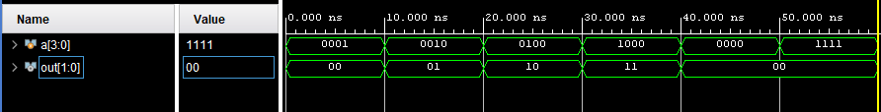
- Encoder 8X3
module encod_8X3(
input [7:0] a,
output reg [2:0] out);

always @(*) begin
case (a)
8'b00000001 : out = 3'b000;
8'b00000010 : out = 3'b001;
8'b00000100 : out = 3'b010;
8'b00001000 : out = 3'b011;
8'b00010000 : out = 3'b100;
8'b00100000 : out = 3'b101;
8'b01000000 : out = 3'b110;
8'b10000000 : out = 3'b111;
default : out = 3'b000;
endcase
end
endmodule
TB
module encod_8X3_tb;
reg [7:0] a;
wire [2:0] out;

encod_8X3 uut (
.a(a),
.out(out)
);

initial begin
a = 8'b00000001; #10;
a = 8'b00000010; #10;
a = 8'b00000100; #10;
a = 8'b00001000; #10;
a = 8'b00010000; #10;
a = 8'b00100000; #10;
a = 8'b01000000; #10;
a = 8'b10000000; #10;
a = 8'b00000000; #10;
a = 8'b11111111; #10;
$finish;
end
endmodule
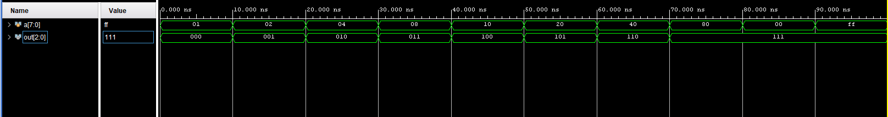
- Priority Encoder 8X3
module pencod_8X3(
input [7:0] a,
output reg [2:0] out);

always @(*) begin
casez (a)
8'b00000000 : out = 3'b000;
8'b00000001 : out = 3'b000;
8'b0000001? : out = 3'b001;
8'b000001?? : out = 3'b010;
8'b00001??? : out = 3'b011;
8'b0001???? : out = 3'b100;
8'b001????? : out = 3'b101;
8'b01?????? : out = 3'b110;
8'b1??????? : out = 3'b111;

endcase
end
endmodule
TB
module pencod_8X3_tb;
reg [7:0] a;
wire [2:0] out;

pencod_8X3 uut(a, out);

initial begin
a = 8'b00000000; #10;
a = 8'b00000001; #10;
a = 8'b00000010; #10;
a = 8'b00000100; #10;
a = 8'b00001000; #10;
a = 8'b00010000; #10;
a = 8'b00100000; #10;
a = 8'b01000000; #10;
a = 8'b10000000; #10;
a = 8'b11111111; #10;
a = 8'b00000011; #10;
a = 8'b00000111; #10;
a = 8'b00001111; #10;
$finish;
end
endmodule
- 1 Bit Comparator
module comp1(
input a, b,
output reg l ,e, g);
initial begin
e = 0;
l = 0;
g = 0;
end
always @(*) begin
if (a > b) begin
g = 1'b1; l = 0; e = 0;
end
else if ( a < b) begin
l = 1; g =0; e = 0;
end
else
e = 1; g = 0; l = 0;
end

endmodule
TB
module comp1_tb;
reg a, b;
wire l, e, g;

comp1 uut(a, b, l, e, g);

initial begin
a = 0; b = 0; #10;
a = 0; b = 1; #10;
a = 1; b = 0; #10;
a = 1; b = 1; #10;
$finish;
end
endmodule
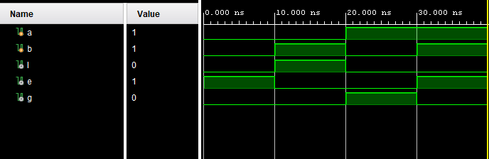
- 2 Bit Comparator
module comp2(
input [1:0] a,b,
output reg l,e,g );

always @(*) begin
if (a>b) begin
g = 1;
l = 0;
e = 0;
end
else if (a<b) begin
l = 1;
g = 0;
e = 0;
end
else begin
e = 1;
l = 0;
g = 0;
end
end

endmodule
TB
module comp2_tb;
reg [1:0] a, b;
wire l, e, g;

comp2 uut(a, b, l, e, g);

initial begin
a = 2'b00; b = 2'b00; #10;
a = 2'b00; b = 2'b01; #10;
a = 2'b01; b = 2'b00; #10;
a = 2'b10; b = 2'b10; #10;
a = 2'b11; b = 2'b10; #10;
a = 2'b10; b = 2'b11; #10;
$finish;
end
endmodule
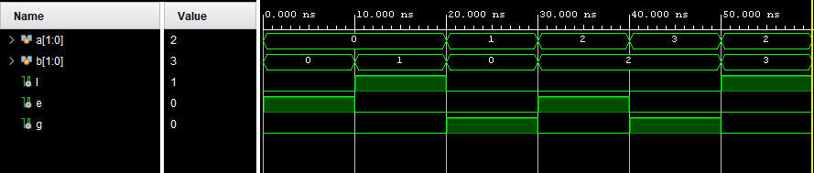
- 4 Bit Comparator
module comp4(
input [3:0] a,b,
output reg l,e,g );

always @(*) begin
if (a>b) begin
g = 1;
l = 0;
e = 0;
end
else if (a<b) begin
l = 1;
g = 0;
e = 0;
end
else begin
e = 1;
l = 0;
g = 0;
end
end

endmodule
TB
module comp4_tb;
reg [3:0] a, b;
wire l, e, g;

comp4 uut(a, b, l, e, g);

initial begin
a = 4'b0000; b = 4'b0000; #10;
a = 4'b0010; b = 4'b0001; #10;
a = 4'b0001; b = 4'b0010; #10;
a = 4'b1111; b = 4'b1111; #10;
a = 4'b1001; b = 4'b0110; #10;
a = 4'b0011; b = 4'b1010; #10;
$finish;
end
endmodule
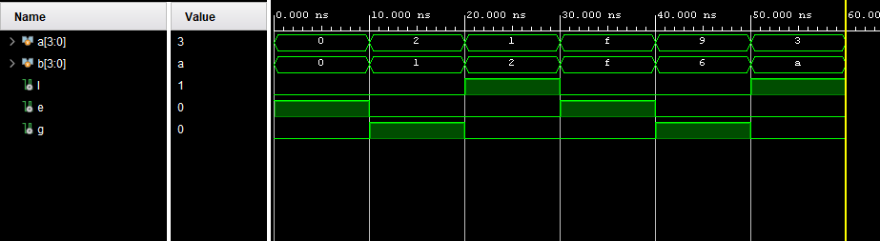
- 8 Bit Comparator
module comp8(
input [7:0] a,b,
output reg l,e,g );

always @(*) begin
if (a>b) begin
g = 1;
l = 0;
e = 0;
end
else if (a<b) begin
l = 1;
g = 0;
e = 0;
end
else begin
e = 1;
l = 0;
g = 0;
end
end

endmodule
TB
module comp8_tb;
reg [7:0] a, b;
wire l, e, g;

comp8 uut(a, b, l, e, g);

initial begin
a = 8'd0; b = 8'd0; #10;
a = 8'd45; b = 8'd32; #10;
a = 8'd10; b = 8'd75; #10;
a = 8'd255; b = 8'd255; #10;
a = 8'd100; b = 8'd99; #10;
a = 8'd5; b = 8'd120; #10;
$finish;
end
endmodule
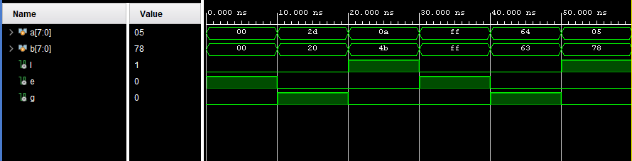
- Greater Than Comparator
module compgt(
input [7:0] a,b,
output reg g );

always @(*) begin
if (a>b)
g = 1;

else
g = 0;
end

endmodule
TB
module compgt_tb;
reg [7:0] a, b;
wire l, e, g;

compgt uut(a, b, l, e, g);

initial begin
a = 8'd0; b = 8'd0; #10;
a = 8'd45; b = 8'd32; #10;
a = 8'd10; b = 8'd75; #10;
a = 8'd255; b = 8'd255; #10;
a = 8'd100; b = 8'd99; #10;
a = 8'd5; b = 8'd120; #10;
$finish;
end
endmodule
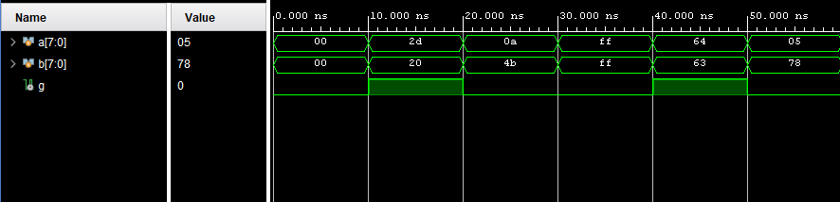
- 4 Bit Carry Look Ahead Adder
module cla4 (
input [3:0] a, b,
input cin,
output [3:0] sum,
output cout
);
wire [3:0] g, p, c;

assign g = a & b;
assign p = a ^ b;

assign c[0] = cin;
assign c[1] = g[0] | (p[0] & c[0]);
assign c[2] = g[1] | (p[1] & g[0]) | (p[1] & p[0] & c[0]);
assign c[3] = g[2] | (p[2] & g[1]) | (p[2] & p[1] & g[0]) | (p[2] & p[1] & p[0] & c[0]);

assign sum = p ^ c;
assign cout = g[3] | (p[3] & g[2]) | (p[3] & p[2] & g[1]) |
(p[3] & p[2] & p[1] & g[0]) |
(p[3] & p[2] & p[1] & p[0] & cin);
Endmodule
TB
module cla4_TB;
reg [3:0] a, b;
reg cin;
wire [3:0] sum;
wire cout;

cla4 uut (
.a(a), .b(b), .cin(cin),
.sum(sum), .cout(cout)
);

initial begin
a = 4'b0000; b = 4'b0000; cin = 0;
#10 a = 4'b0001; b = 4'b0001; cin = 0;
#10 a = 4'b0011; b = 4'b0101; cin = 1;
#10 a = 4'b1111; b = 4'b0001; cin = 0;
#10 a = 4'b1010; b = 4'b0101; cin = 1;
#10 $finish;
end
endmodule
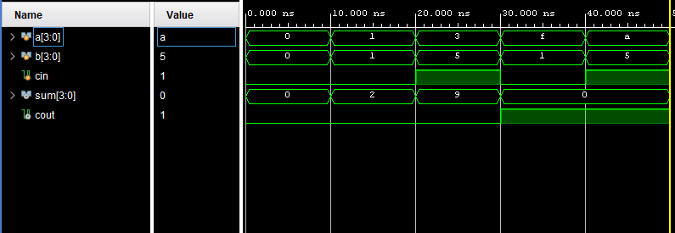
- 4 Bit Binary Multiplier
module mult4 (
input [3:0] a, b,
output [7:0] product
);
wire [7:0] p0 = b[0] ? {4'b0000, a} : 8'b0;
wire [7:0] p1 = b[1] ? {3'b000, a, 1'b0} : 8'b0;
wire [7:0] p2 = b[2] ? {2'b00, a, 2'b00} : 8'b0;
wire [7:0] p3 = b[3] ? {1'b0, a, 3'b000} : 8'b0;

assign product = p0 + p1 + p2 + p3;
endmodule
TB
module mult4_TB;
reg [3:0] a, b;
wire [7:0] product;

mult4 uut (
.a(a), .b(b),
.product(product)
);

initial begin
a = 4'b0000; b = 4'b0000;
#10 a = 4'b0010; b = 4'b0011;
#10 a = 4'b1111; b = 4'b0001;
#10 a = 4'b1010; b = 4'b0101;
#10 a = 4'b1111; b = 4'b1111;
#10 $finish;
end
endmodule
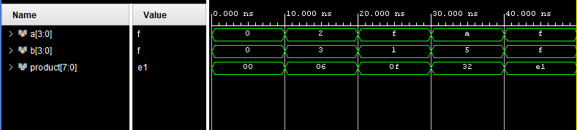
- Booth Multiplier
module booth_multiplier (
input [3:0] multiplicand,
input [3:0] multiplier,
output [7:0] product
);
reg [7:0] A, S, P;
reg [3:0] M, Q;
integer i;

always @(*) begin
A = {multiplicand, 4'b0000};
S = {~multiplicand + 1'b1, 4'b0000};
P = {4'b0000, multiplier, 1'b0};

for (i = 0; i < 4; i = i + 1) begin
case (P[1:0])
2'b01: P = P + A;
2'b10: P = P + S;
default: P = P;
endcase
P = {P[7], P[7:1]}; // arithmetic right shift
end
end

assign product = P[7:0];
endmodule
TB
module booth_multiplier_TB;
reg [3:0] multiplicand, multiplier;
wire [7:0] product;

booth_multiplier uut (
.multiplicand(multiplicand),
.multiplier(multiplier),
.product(product)
);

initial begin
multiplicand = 4'd3; multiplier = 4'd2; #10;
multiplicand = 4'd4; multiplier = 4'd3; #10;
multiplicand = 4'd7; multiplier = 4'd5; #10;
multiplicand = 4'd8; multiplier = 4'd8; #10;
multiplicand = 4'd15; multiplier = 4'd15; #10;
$finish;
end
endmodule
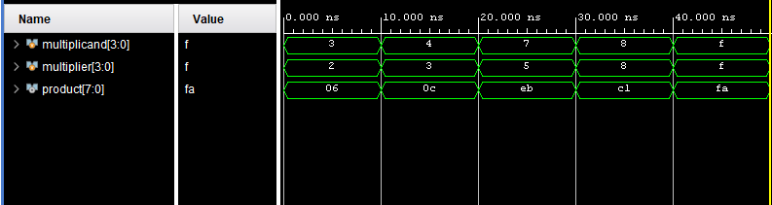
- Array Multiplier
module array_multiplier (
input [3:0] a,
input [3:0] b,
output [7:0] product
);
wire [3:0] p0, p1, p2, p3;
wire [7:0] s1, s2, s3;

assign p0 = a & {4{b[0]}};
assign p1 = a & {4{b[1]}};
assign p2 = a & {4{b[2]}};
assign p3 = a & {4{b[3]}};

assign s1 = {1'b0, p1, 1'b0}; // shifted left by 1
assign s2 = {2'b0, p2, 2'b0}; // shifted left by 2
assign s3 = {3'b0, p3, 3'b0}; // shifted left by 3

assign product = {4'b0000, p0} + s1 + s2 + s3;
endmodule
TB
module array_multiplier_TB;
reg [3:0] a, b;
wire [7:0] product;

array_multiplier uut (
.a(a),
.b(b),
.product(product)
);

initial begin
a = 4'd3; b = 4'd2; #10;
a = 4'd4; b = 4'd5; #10;
a = 4'd7; b = 4'd3; #10;
a = 4'd8; b = 4'd8; #10;
a = 4'd15; b = 4'd15; #10;
$finish;
end
endmodule
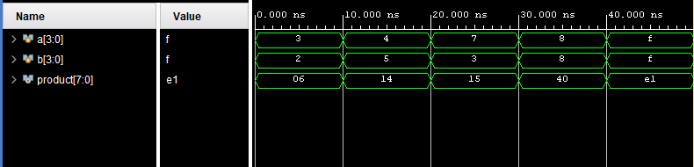
- Divider using Repeated Subtraction
module divider_subtract (
input [3:0] dividend,
input [3:0] divisor,
output reg [3:0] quotient,
output reg [3:0] remainder
);
integer i;
reg [3:0] temp_dividend;

always @(*) begin
quotient = 0;
remainder = 0;
temp_dividend = dividend;

if (divisor == 0) begin
quotient = 4'b0000;
remainder = dividend;
end else begin
while (temp_dividend >= divisor) begin
temp_dividend = temp_dividend - divisor;
quotient = quotient + 1;
end
remainder = temp_dividend;
end
end
endmodule
TB
module divider_subtract_TB;
reg [3:0] dividend, divisor;
wire [3:0] quotient, remainder;

divider_subtract uut (
.dividend(dividend),
.divisor(divisor),
.quotient(quotient),
.remainder(remainder)
);

initial begin
dividend = 4'd10; divisor = 4'd3; #10;
dividend = 4'd15; divisor = 4'd4; #10;
dividend = 4'd9; divisor = 4'd2; #10;
dividend = 4'd8; divisor = 4'd0; #10;
dividend = 4'd7; divisor = 4'd7; #10;
$finish;
end
endmodule
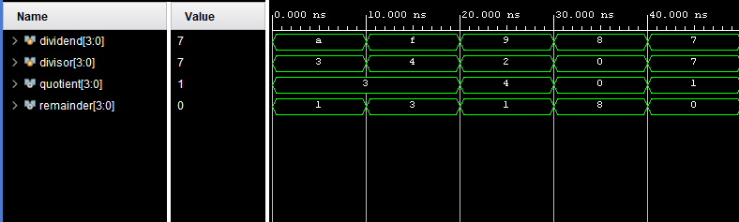
- D -Flip Flop
module d_ff (
input d,
input clk,
output reg q
);
always @(posedge clk)
q <= d;
endmodule
TB
module d_ff_TB;
reg d, clk;
wire q;

d_ff uut (
.d(d),
.clk(clk),
.q(q)
);

initial begin
clk = 0;
forever #5 clk = ~clk;
end

initial begin
d = 0; #10;
d = 1; #10;
d = 0; #10;
d = 1; #10;
d = 1; #10;
d = 0; #10;
$finish;
end
endmodule
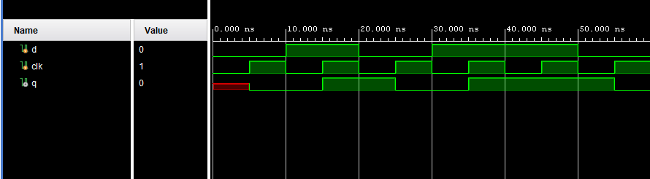
- T Flip Flop
module t_ff (
input t,
input clk,
output reg q
);
always @(posedge clk) begin
if (t)
q <= ~q;
end
endmodule
TB
module t_ff_TB;
reg t, clk;
wire q;

t_ff uut (
.t(t),
.clk(clk),
.q(q)
);

initial begin
clk = 0;
forever #5 clk = ~clk;
end

initial begin
t = 0; #10;
t = 1; #10;
t = 1; #10;
t = 0; #10;
t = 1; #10;
t = 1; #10;
$finish;
end
endmodule
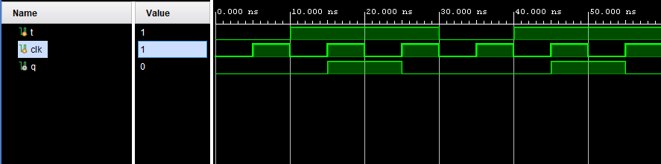
- JK Flip Flop
module jk_ff (
input j, k, clk,
output reg q
);
always @(posedge clk) begin
case ({j, k})
2'b00: q <= q;
2'b01: q <= 0;
2'b10: q <= 1;
2'b11: q <= ~q;
endcase
end
endmodule
TB
module jk_ff_TB;
reg j, k, clk;
wire q;

jk_ff uut (
.j(j),
.k(k),
.clk(clk),
.q(q)
);

initial begin
clk = 0;
forever #5 clk = ~clk;
end

initial begin
j = 0; k = 0; #10;
j = 0; k = 1; #10;
j = 1; k = 0; #10;
j = 1; k = 1; #10;
j = 0; k = 1; #10;
j = 1; k = 1; #10;
$finish;
end
endmodule
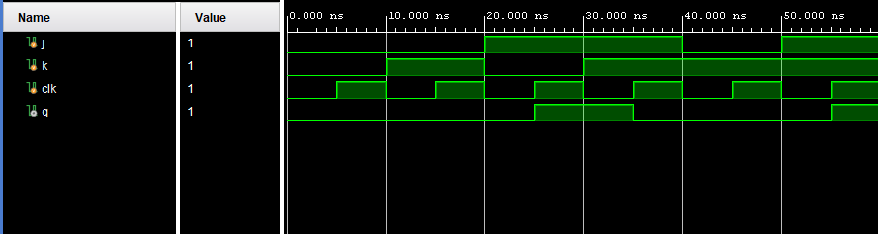
- SR Flip Flop
module sr_ff (
input s, r, clk,
output reg q
);
always @(posedge clk) begin
case ({s, r})
2'b00: q <= q;
2'b01: q <= 0;
2'b10: q <= 1;
2'b11: q <= 1'bx; // Invalid condition
endcase
end
endmodule
TB
module sr_ff_TB;
reg s, r, clk;
wire q;

sr_ff uut (
.s(s),
.r(r),
.clk(clk),
.q(q)
);

initial begin
clk = 0;
forever #5 clk = ~clk;
end

initial begin
s = 0; r = 0; #10;
s = 1; r = 0; #10;
s = 0; r = 1; #10;
s = 1; r = 1; #10;
s = 0; r = 0; #10;
$finish;
end
endmodule
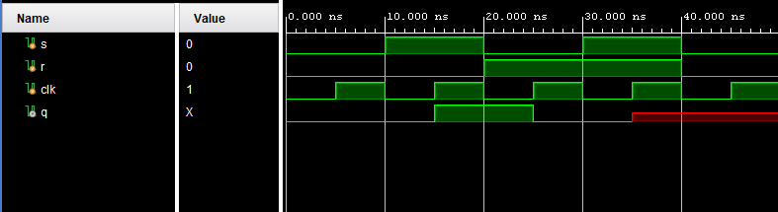
- Master-Slave Flip-Flop
module ms_d_ff(
input d, clk,
output reg q
);
reg master;

always @(posedge clk)
master <= d;

always @(negedge clk)
q <= master;
endmodule
TB
module ms_d_ff_TB;
reg d, clk;
wire q;

ms_d_ff uut (
.d(d),
.clk(clk),
.q(q)
);

initial begin
clk = 0;
forever #5 clk = ~clk;
end

initial begin
d = 0; #10;
d = 1; #10;
d = 0; #10;
d = 1; #10;
d = 1; #10;
d = 0; #10;
$finish;
end
endmodule
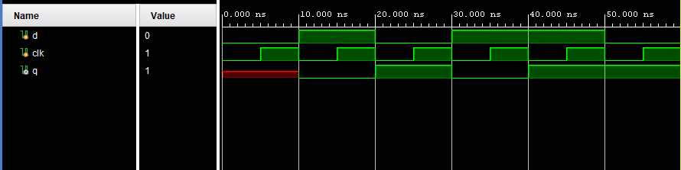
- 4-bit Register with Positive Clock Edge
module reg4bit(
input [3:0] d,
input clk,
output reg [3:0] q
);

always @(posedge clk)
q <= d;

endmodule
TB
module reg4bit_TB;
reg [3:0] d;
reg clk;
wire [3:0] q;

reg4bit uut (
.d(d),
.clk(clk),
.q(q)
);

initial begin
clk = 0;
forever #5 clk = ~clk;
end

initial begin
d = 4'b0000; #10;
d = 4'b1010; #10;
d = 4'b1111; #10;
d = 4'b0101; #10;
d = 4'b0011; #10;
$finish;
end
endmodule
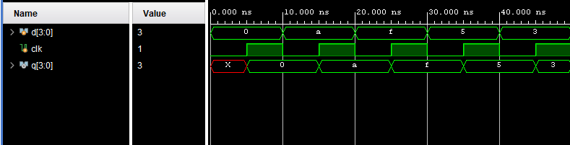
- 4-bit Shift Register (Left)
module shift_register_left(
input clk,
input rst,
input in,
output reg [3:0] q
);

always @(posedge clk or posedge rst) begin
if (rst)
q <= 4'b0000;
else
q <= {q[2:0], in};
end

endmodule
TB
module shift_register_left_TB;
reg clk;
reg rst;
reg in;
wire [3:0] q;

shift_register_left uut (
.clk(clk),
.rst(rst),
.in(in),
.q(q)
);

initial begin
clk = 0;
forever #5 clk = ~clk;
end

initial begin
rst = 1; in = 0; #10;
rst = 0; in = 1; #10;
in = 0; #10;
in = 1; #10;
in = 1; #10;
in = 0; #10;
$finish;
end
endmodule
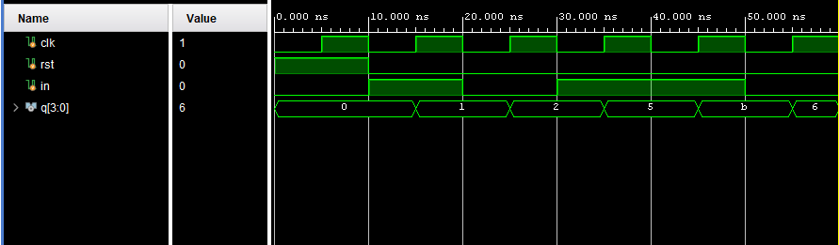
- 4-bit Shift Register (Right)
module shift_register_right(
input clk,
input rst,
input in,
output reg [3:0] q
);

always @(posedge clk or posedge rst) begin
if (rst)
q <= 4'b0000;
else
q <= {in, q[3:1]};
end

endmodule
TB
module shift_register_right_TB;
reg clk;
reg rst;
reg in;
wire [3:0] q;

shift_register_right uut (
.clk(clk),
.rst(rst),
.in(in),
.q(q)
);

initial begin
clk = 0;
forever #5 clk = ~clk;
end

initial begin
rst = 1; in = 0; #10;
rst = 0; in = 1; #10;
in = 0; #10;
in = 1; #10;
in = 1; #10;
in = 0; #10;
$finish;
end
endmodule
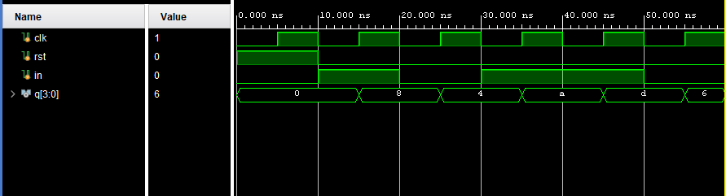
- Bidirectional Shift Register
module shift_register_bidir(
input clk,
input rst,
input dir, // 0 = left, 1 = right
input in,
output reg [3:0] q
);

always @(posedge clk or posedge rst) begin
if (rst)
q <= 4'b0000;
else if (dir) // Right shift
q <= {in, q[3:1]};
else // Left shift
q <= {q[2:0], in};
end

endmodule
TB
module shift_register_bidir_TB;
reg clk;
reg rst;
reg dir;
reg in;
wire [3:0] q;

shift_register_bidir uut (
.clk(clk),
.rst(rst),
.dir(dir),
.in(in),
.q(q)
);

initial begin
clk = 0;
forever #5 clk = ~clk;
end

initial begin
rst = 1; dir = 0; in = 0; #10;
rst = 0;
in = 1; #10; // left shift in 1
in = 0; #10; // left shift in 0
dir = 1;
in = 1; #10; // right shift in 1
in = 0; #10; // right shift in 0
$finish;
end
endmodule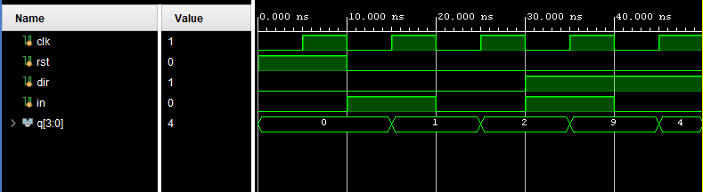
- Parallel-In Parallel-Out Register
module pipo_register (
input clk,
input rst,
input [3:0] d,
output reg [3:0] q
);

always @(posedge clk or posedge rst) begin
if (rst)
q <= 4'b0000;
else
q <= d;
end

endmodule
TB
module pipo_register_TB;
reg clk;
reg rst;
reg [3:0] d;
wire [3:0] q;

pipo_register uut (
.clk(clk),
.rst(rst),
.d(d),
.q(q)
);

initial begin
clk = 0;
forever #5 clk = ~clk;
end

initial begin
rst = 1; d = 4'b0000; #10;
rst = 0; d = 4'b1010; #10;
d = 4'b1100; #10;
d = 4'b0111; #10;
$finish;
end
endmodule
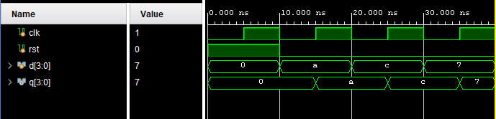
- 4-bit Asynchronous Counter
module async_counter_4bit (
input clk,
input rst,
output reg [3:0] count
);

always @(negedge clk or posedge rst) begin
if (rst)
count <= 4'b0000;
else
count <= count + 1;
end

endmodule
TB
module tb_async_counter_4bit;

reg clk, rst;
wire [3:0] count;

async_counter_4bit uut (
.clk(clk),
.rst(rst),
.count(count)
);

initial begin
clk = 0;
forever #5 clk = ~clk;
end

initial begin
rst = 1;
#10 rst = 0;
#100 $finish;
end

endmodule
- 4-bit Synchronous Counter
module sync_counter_4bit(
input clk,
input rst,
output reg [3:0] count
);

always @(posedge clk or posedge rst) begin
if (rst)
count <= 4'b0000;
else
count <= count + 1;
end

endmodule
TB
module sync_counter_4bitTB;

reg clk, rst;
wire [3:0] count;

sync_counter_4bit uut (
.clk(clk),
.rst(rst),
.count(count)
);

initial begin
clk = 0;
forever #5 clk = ~clk;
end

initial begin
rst = 1;
#10 rst = 0;
#100 $finish;
end

endmodule
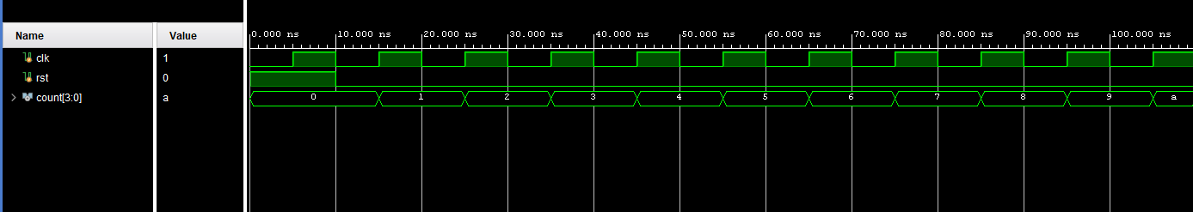
- Up Counter
module up_counter(
input clk,
input rst,
output reg [3:0] count
);

always @(posedge clk or posedge rst) begin
if (rst)
count <= 4'b0000;
else
count <= count + 1;
end

endmodule
TB
module up_counterTB;

reg clk, rst;
wire [3:0] count;

up_counter uut (
.clk(clk),
.rst(rst),
.count(count)
);

initial begin
clk = 0;
forever #5 clk = ~clk;
end

initial begin
rst = 1;
#10 rst = 0;
#100 $finish;
end

endmodule
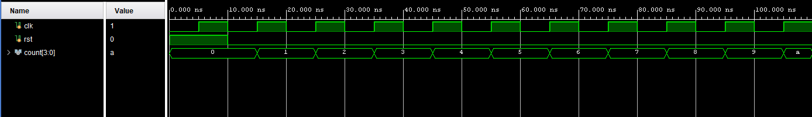
- Down Counter
module down_counter(
input clk,
input rst,
output reg [3:0] count
);

always @(posedge clk or posedge rst) begin
if (rst)
count <= 4'b1111;
else
count <= count - 1;
end

endmodule
TB
module down_counterTB;

reg clk, rst;
wire [3:0] count;

down_counter uut (
.clk(clk),
.rst(rst),
.count(count)
);

initial begin
clk = 0;
forever #5 clk = ~clk;
end

initial begin
rst = 1;
#10 rst = 0;
#100 $finish;
end

endmodule
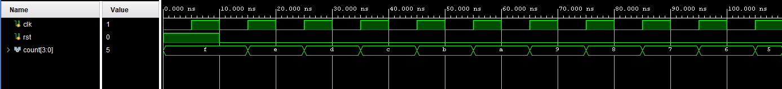
- Up/Down Counter
module up_down_counter(
input clk,
input rst,
input up_down, // 1: up, 0: down
output reg [3:0] count
);

always @(posedge clk or posedge rst) begin
if (rst)
count <= 4'b0000;
else if (up_down)
count <= count + 1;
else
count <= count - 1;
end

endmodule
TB
module up_down_counterTB;

reg clk, rst, up_down;
wire [3:0] count;

up_down_counter uut (
.clk(clk),
.rst(rst),
.up_down(up_down),
.count(count)
);

initial begin
clk = 0;
forever #5 clk = ~clk;
end

initial begin
rst = 1; up_down = 1;
#10 rst = 0;
#50 up_down = 0;
#50 $finish;
end

endmodule